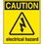
If at any time one of your components gets hot, immediately disconnect your battery, consider the probable cause, and then discuss the issues and corrective action with one of the student instructors.

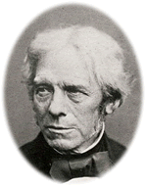
1. Draw a circle around the correct circuit symbol for a capacitor.

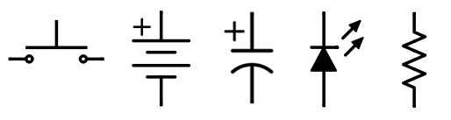

2. What does a capacitor store?
Michael Faraday 1791-1867
3. What is the unit of measure of capacitance?

4. Identify this Greek letter, μ?

5. What is the size of the capacitor in your kit (include the units)?
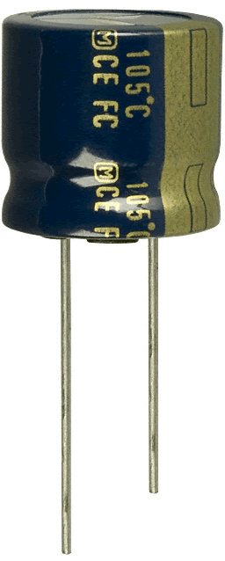
6. What are the two ways you can tell the electrolytic capacitor in your kit is polarized?

a)

b)

7. In the table below, identify whether the arranagement of the components depicted are in series or in parallel (Circle one for each)
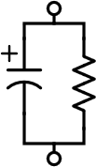  Series or Parallel? | 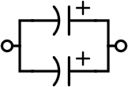  Series or Parallel?
Series or Parallel? | Series or Parallel?
Series or Parallel? | Series or Parallel?

