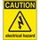
Circuits: FirstSteps
If at any time one of your components gets hot, immediately disconnect your battery. Consider the probable cause and then undertake the corrective action.

1. Before You Start
Since an LED has a positive leg (anode) and a negative leg (cathode) it must be inserted into a circuit with the correct orientation. How can you tell which leg is which by simply looking at the LED? Is there another way?

2. From Schematic to Breadboard
You are encouraged to look online for circuits that you may wish to breadboard or simply to learn from. Circuit diagrams are typically presented in the form of a schematic that is meant to convey how the components are connected, not necessarily how there are supposed to be laid out on a breadboard.

A simple schematic is presented below left and its breadboard prototype appears below right.

Schematic | Breadboard
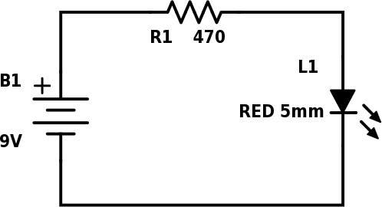 | 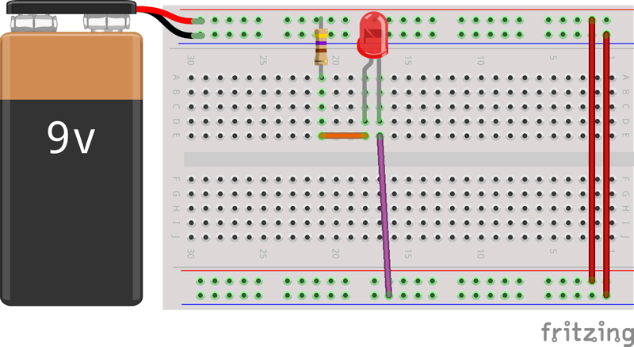

a) [Observation and Reflection] Look carefully at the schematic, noting the connections between the three components. Which leg of the LED is connected to the resistor?

b) [Analysis and Communication] Explain the path the electrons take in travelling around the circuit.

3. Circuit Analysis 1. Voltage Considerations
- A device that measures the voltage consumed by a component is called, naturally, a voltmeter.
- To measure the voltage consumed, or dropped as it is typically referred to, the device is placed in parallel with the leads of the component.
- The circuit symbol for a voltmeter is a V within a circle.
- The schematic below is the same as the one on the previous page with the exception that a voltmeter symbol has been placed in parallel around each of the three components.

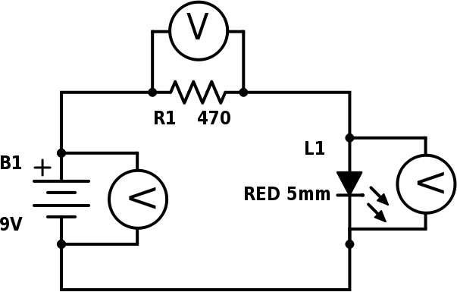

Kirchhoff’s Voltage Law (KVL) states that the entire voltage of the power source
is used up in a working circuit.

Let’s confirm Kirchhoff’s Voltage Law with our Digital Multimeter (DMM).

a) With your battery disconnected, measure the voltage of your power source. _______V

Breadboard a circuit from the schematic and connect your battery. The LED should be on.

b) Measure the voltage drop across the battery, B1. _______V
c) Measure the voltage drop across the resistor, R1. _______V
d) Measure the voltage drop across the LED, L1. _______V

Question. Do your results from b), c), and d) confirm Kirchhoff’s Voltage Law? _________

