Variable Resistance: The Potentiometer

If at any time one of your components gets hot, immediately disconnect your battery, consider the probable cause, and then discuss the issues and corrective action with one of the student instructors.

1. Ohm’s Law
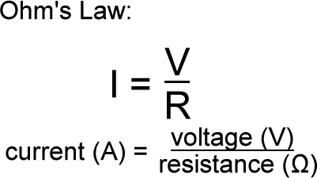
As we explored in class, Ohm’s Law provides a general guideline for circuit design. Looking at the formula, you can deduce that if the voltage is increased, current is also increased.
On the other hand if the resistance is increased, the current is decreased.

Since the brightness of an LED is directly related to current, resistance plays an important role.

Example
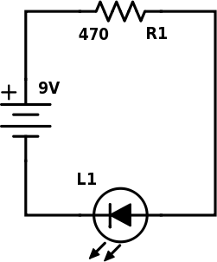
The goal of the circuit designer is to have a single LED light up safely with reasonable brightness. Since LED brightness is sensitive to the current, the designer checks online and determines that 20mA is the optimum level. Here’s why the 470Ω resistor was a good choice:

$$\frac{V}{R}=\frac{9}{470}=0.0191≈20mA$$

Replacing the 470Ω resistor with the 1000Ω resistor would reduce the current to 9mA making the LED appear dimmer (but it would last longer!)

2. The Potentiometer
Unlike the two fixed resistor values you received in your ProtoKit (470Ω and 1000Ω or 1kΩ) the potentiometer offers variable resistance by rotating the shaft (like a volume know on a radio or a dimmer in your dining room) See the lesson on our course page for an animation of the graphic below.

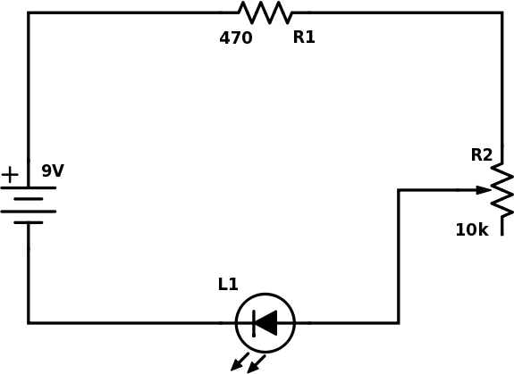
Exercise
1. Using the schematic to the right, wire up the circuit on your spare breadboard, before plugging in your battery. Note that the B leg of the potentiometer remains unconnected.
2. Plug in your battery and rotate the shaft of the potentiometer to its most clockwise and counter clockwise positions, noting the effect the actions have on the brightness level of the LED

Please answer the following questions,

a) From class, what the does the number 103 stamped on the potentiometer mean?

b) The middle pin on the potentiometer is referred to as the C leg. How much resistance does this device provide when C is rotated all the way to A? Ω
c) How much resistance does this device provide when C is rotated all the way to B? Ω
d) Using Ohm’s Law, determine the current in the circuit when C is positioned halfway between A and B.

2. Common Potentiometer Oversights, Mistakes, Problems, and Issues
The intent of the half-size prototypes below is to have the LED brightness change with the turning of the potentiometer. In each of the two cases below, identify the oversight, mistake, problem, or issue that prevents the objective from being realized.

a)  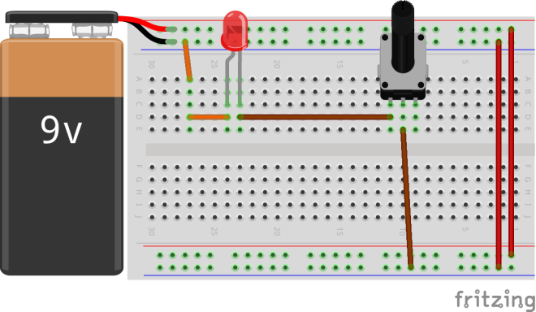 | b)  