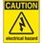
If at any time one of your components gets hot, immediately disconnect your battery, consider the probable cause, and then discuss the issues and corrective action with one of the student instructors.

Variable Resistance: The Light Dependent Resistor

You’ve been introduced to fixed resistors and a variable resistor known by the name potentiometer. The potentiometer (or pot for short) changes resistance as the shaft is rotated either manually, or electrically, as is in the case of a servo motor.

In this worksheet you will explore a second type of variable resistor, a light dependent resistor (LDR, for short) whose resistance varies in relation to amount of light that falls on its head (shown to the right).

Questions
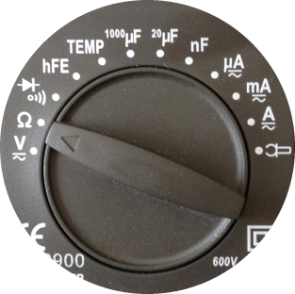
1. Are the two leads of the LDR arranged in axial or radial format?

2. a) Place the LDR in your breadboard, free from connection to any other parts. Using your digital Multimeter (DMM) measure and record the resistance the LDR offers in the normal light of the room.

____________Ω
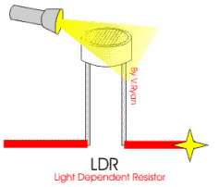
b) If you have one, shine a flashlight (or even the bright light from your phone) on the head of the LDR and record the resistance again.

____________Ω

c) If you have a pen cap, or something similar, cover up the head of the LDR. Measure and record the resistance one more time.

____________Ω

d) From the results of your measurements, would you say that, for the LDR, are light and resistance related directly or indirectly. Explain your conclusion to your partner.

2. a) Consider the schematic below left. Do not assemble the circuit on your breadboard.
What do you think; in normal light would the LED be on or off? If you said yes, would it be visible? Why or why not?

b) Breadboard the circuit below left to test your prediction. Reflection: Were you correct or had you missed something?

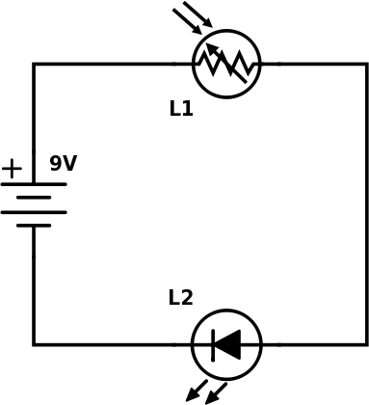 | 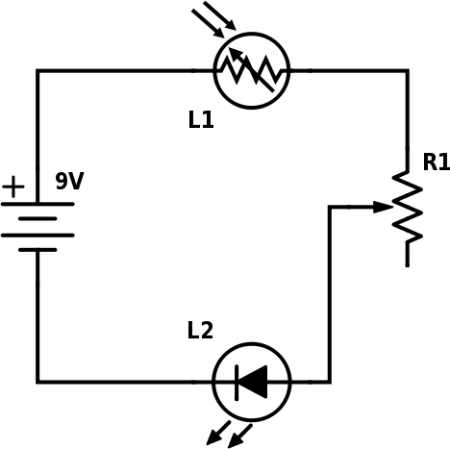
c) Consider the circuit above right.

i) Which leg of the potentiometer remains unconnected? Circle one. A B C

ii) What purpose does the potentiometer serve?

iii) Assemble a prototype of this circuit on your breadboard and test it.

