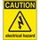
If at any time one of your components gets hot, immediately disconnect your battery, consider the probable cause, and then discuss the issues and corrective action with one of the student instructors.

Buttons and Switches
In each of the button/switch configurations, identify the outcome as either problematic or useful, providing a reason for your conclusion.

a)  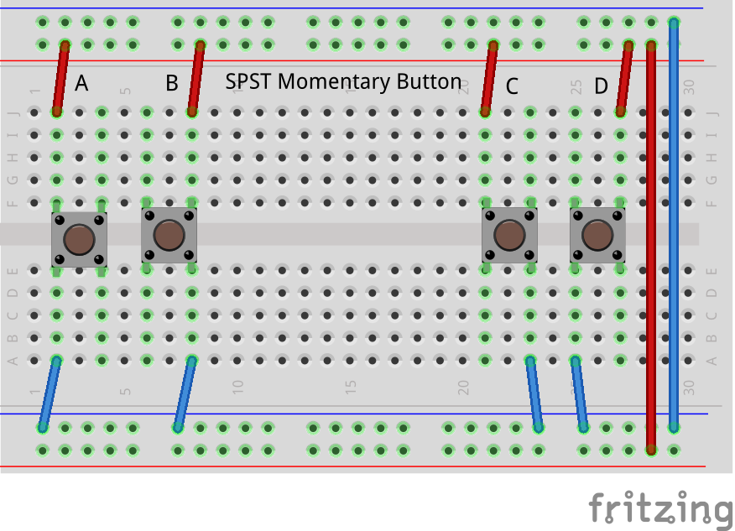  A  B  C  D | b)  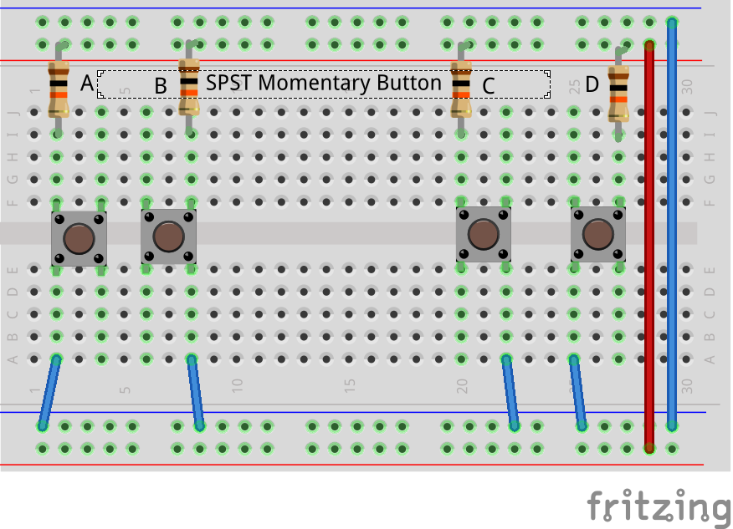  A  B  C  D
c)  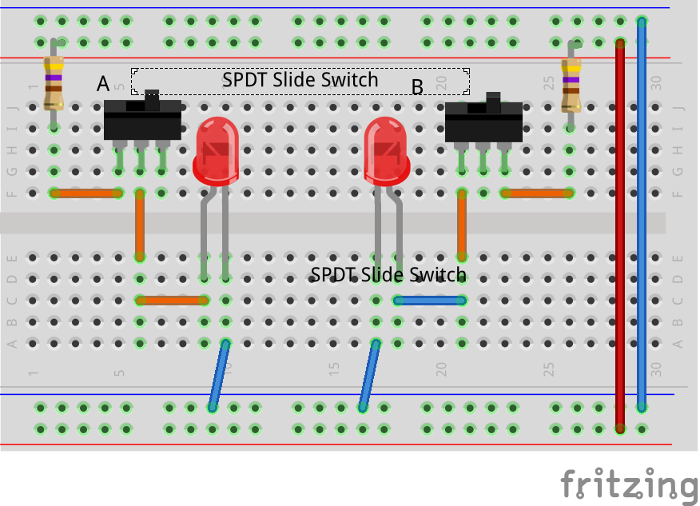  A  B | d)  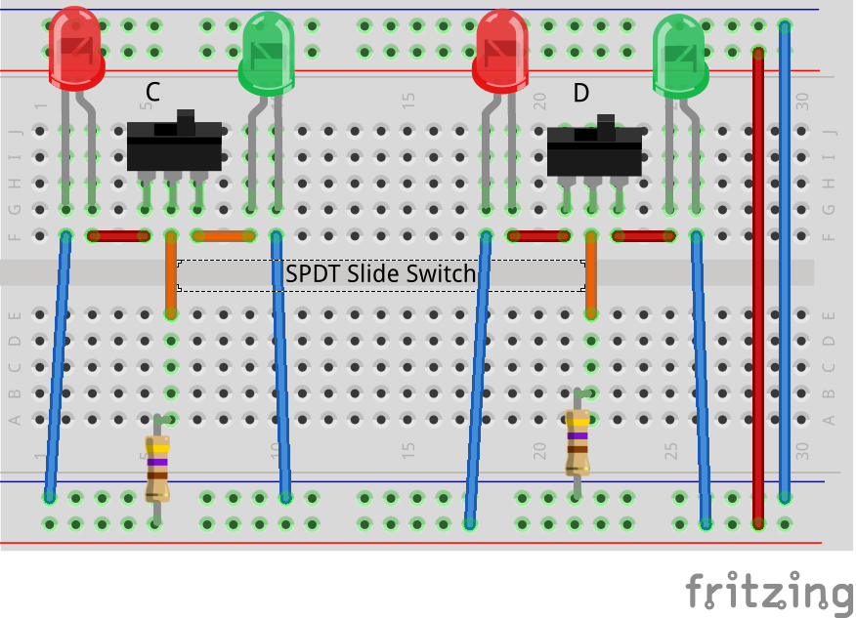  C  D

