Using the ACES’ ProtoKit

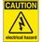
If at any time one of your components gets hot, immediately disconnect your battery, consider the probable cause, and then discuss the issues and corrective action with one of the student instructors.

In our opening workshop we introduced the platform on which your circuit prototypes will be assembled and tested. Knowledge of the underlying connections within the board will help you avoid problems associated with prototyping electric circuits.

1. Breadboard Awareness

a) [Research and Communication] Using your research skills determine the origin of the term breadboard and summarize it in your own words.

b) [Analysis] The image of a single, full size breadboard appears below. Using your arithmetic skills, determine the total number of holes it offers. _______

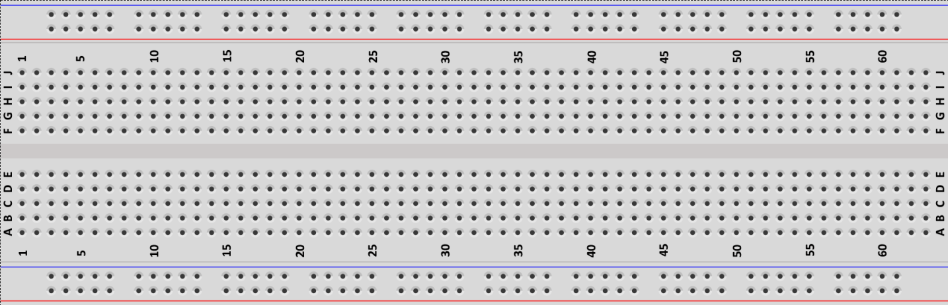

c) [Communication] Describe the organization of the holes.

d) [Communication] Identify any colours you see and suggest what the purpose they might serve.

e) [Knowledge and Thinking] From our previous workshop do you recall whether the holes closest to the red rail at the top connected to the holes closest to the red rails along the bottom?

f) Using the numbers and letters, mark the following specific hole locations with your pencil.

i) A1 ii) E1 iii) G1 iv) J1 v) A2 vi) H25

2. Common Circuit Prototype Oversights, Mistakes, Problems, and Issues
The intent of the half-size prototypes below was to have an LED turn on. In each of the five cases below the circuit did not perform as designed. In the space provided to the left of each image, explain fully the reason for the oversight, mistake, problem, or issue.

Oversight / Mistake / Problem / Issue | Circuit
a) | 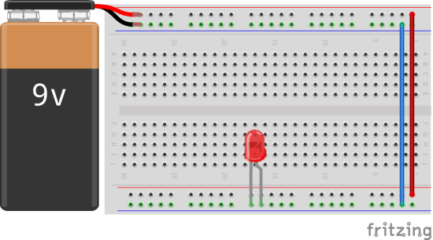
b) | 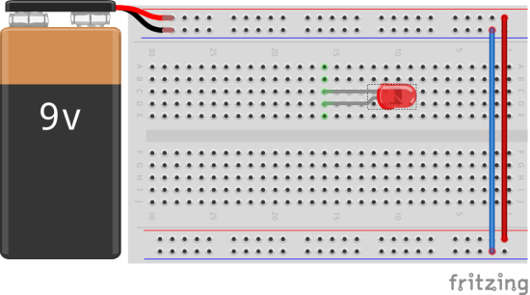
c) | 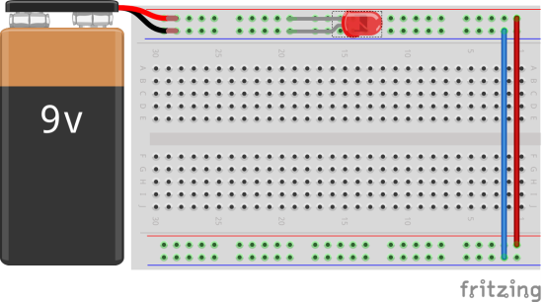
d) | 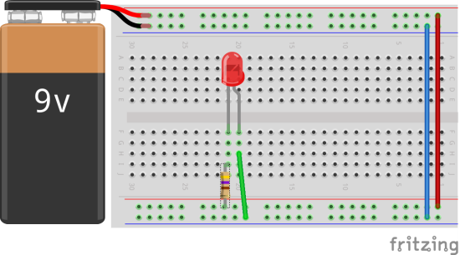
e) | 