TST-58114_45_45.jpgIf at any time one of your components gets **hot**, immediately disconnect your battery, consider the probable cause, and then discuss the issues and corrective action with one of the student instructors.

### A. Single LED Circuit: Measuring Voltage Drop (Waterfall Model)

In Monday’s class we used Excel to assist us with analyzing the electrical characteristics of a single LED-resistor circuit. Here is a summary of our collective effort,

|  |  |
| --- | --- |
| **Normal View** | **Formula View** |
| CircuitDesignCompleted.png | CircuitDesignCompletedFormulaView.png |

It is important to confirm the **theoretical** results of our calculations above in an **actual** working circuit. Set your Digital Multimeter to **DC Voltage**, measure the voltage drop across both the LED and the resistor (in **parallel** with the component) and fill in the readings on the green lines. Additional instructions for this will be provided in class.

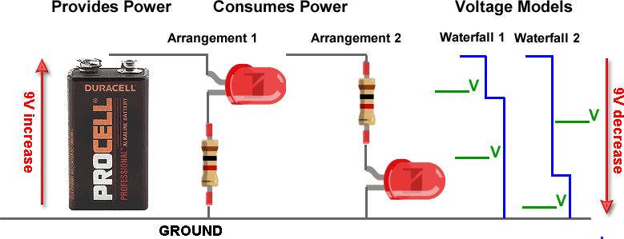

### B. Multiple LED Circuit: Source Voltage Considerations

To ensure the predictable behavior of your *battery* LED Circuits, nothing is more important than considering the **voltage** requirement of your preferred arrangement. So,

1. *Kirchhoff’s Voltage Law* states that **all** the voltage in a working circuit is used up.

2. Consider 16 bright white LEDs, in which the datasheet indicates each requires requires **3V** for optimum performance.

3. Individual alkaline batteries (AAA, AA, C, D) provide **1.5V** each.

**Task**. For each of the four arrangements of 16 LEDs that appear below, indicate the voltage drop between the **positive (*source*)** and **negative (*ground*)** supplies and indicate how many **1.5V** batteries (*in series*) would be required for optimum performance.

|  |  |  |
| --- | --- | --- |
| **Scenario** | **Voltage Drop?** | **Required Number of 1.5V Batteries?** |
| **a** | 3 | 2 (1.5V) |
| **b** | 6 | 4 |
| **c** | 12 | 8 |
| **d** | 3 | 2 |

