TST-58114_45_45.jpgIf at any time one of your components gets **hot**, immediately disconnect your battery, consider the probable cause, and then discuss the issues and corrective action with one of the student instructors.

### Display Design Considerations - PCB

The target platform for your display device is a Quarter-sized Perma-Proto PCB from Adafruit. The description and approximate dimensions can be found at, <https://www.adafruit.com/products/1608>

|  |  |
| --- | --- |
| **Perma-Proto PCB Front** | **Perma-Proto PCB Back** |
| PermaProtoFront.png | PermaProtoBack.png |

### Display Design Considerations – Power and LED Arrangements

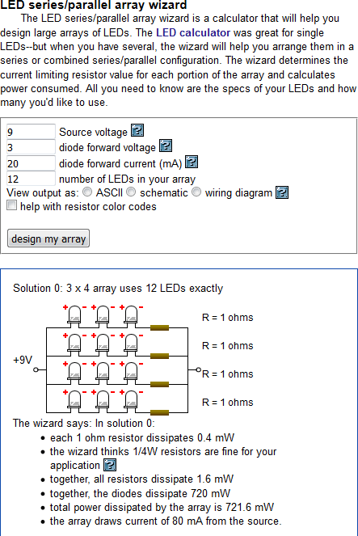The LED Array Wizard found at,

<http://led.linear1.org/led.wiz>

is an indispensable tool to assist with the design of your LED Device. After entering the voltage of your power source together with the number and electrical characteristics of your LEDs,

<http://darcy.rsgc.on.ca/ACES/Junior/Grade6/1516/1246341783_1315.pdf>

the wizard will offer your one or more design recommendations.

### Exercise

Look closely at the image provided at, <http://darcy.rsgc.on.ca/ACES/Junior/Photos/2by4LEDArrangement.png>

Determine by inspection the voltage requirement for each arrangement . **Your Answer**? **Green \_\_\_V Violet\_\_\_\_V**.