1. Shady Business with Venn Diagrams…
For each of the following Venn Diagrams complete the inclusion sentence using words like IN, NOT, AND, OR, to describe what qualifies for set membership in the shaded area(s).

a) | 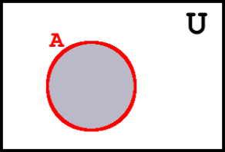 | For example, an element of the shaded area is…  IN (true) the set A  Logic Name: EQU/BUFF/ IN
b) |  | An element of the shaded area is…  NOT IN the set A  Logic Name: NOT/NIN
c) | 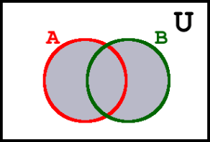 | An element of the shaded area is…  A OR B  Logic Name: OR
d) | 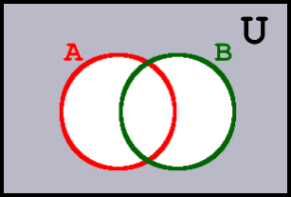 | An element of the shaded area is…  NOT (A OR B)  Logic Name: NOR  Logic Name:______
e) | 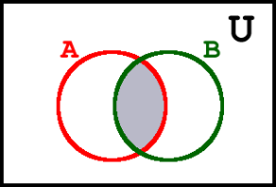 | An element of the shaded area is…  A AND B  Logic Name: AND  Logic Name:______
f) | 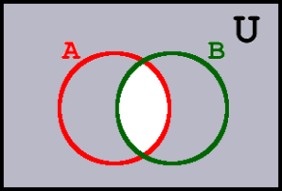 | An element of the shaded area is…  NOT ( A AND B )  Logic Name: NAND
g) | 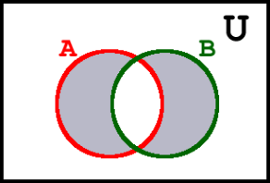 | An element of the shaded area is…  EXCLUSIVE OR  Logic Name: XOR
h) | 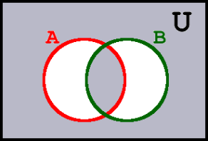 | An element of the shaded area is…  NOT (EXCLUSIVE OR)  Logic Name: XNOR

2. Representing Venn Diagrams as Binary Numbers…
a) In our last class we let set U be the universe of all RSGC students. Let set A stand for the set of all Grade 5 students and set B be set of students that like Brussels sprouts. A really simple way to create a binary number from a Venn Diagram is to let 1 stand for whether someone is in the set and 0 if they are not in the set. Using this strategy the diagram from Question 2 in our previous worksheet can be coded in Binary shown below.

Venn Diagram of Two Sets | Binary Representation of Venn Diagram
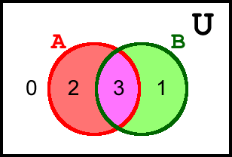 | Base 10 A B  0 0 0  1 0 1  2 1 0  3 1 1

b) In this next exercise you are asked to extend your understanding of the previous question to include three sets.

You might start by filling in the counting sequence of binary numbers in the second column of the table below right, before filling in the equivalent base 10 (decimal) number in the first column.

Finally, use your understanding of the previous question to place the correct decimal number in the appropriate coloured region in the Venn Diagram.

Venn Diagram of Three Sets | Binary Representation of Venn Diagram
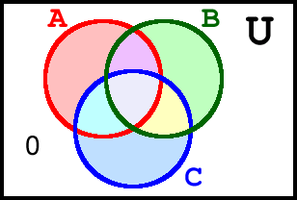 | Base 10 A B C  0 0 0 0

Reference: https://github.com/lawrancej/COMP278-2014/blob/master/lectures/lecture3.adoc

