1. Math Machines
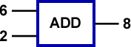
The expression $6+2$ combines the two operands (6 and 2) with the addition operator (+) to produce a result of 8. The equation $6+2=8$ can be depicted graphically as shown to the right. We can interpret this as 6 and 2 being the inputs to the ADD machine and 8 as the output!

a) Similar math machines can be depicted for subtraction, multiplication and division. Supply the missing inputs and outputs to the SUB, MUL and DIV math machines below.

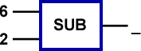 | 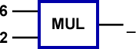 | 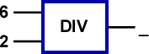

b) What choices do we have for the inputs to these math machines?

c) Is there a machine that will break down if you feed it the wrong input?

d) If we know only one input and the output, can we determine what the other input must be? If so, complete the following machines.

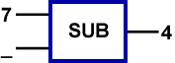 | 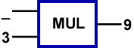 | 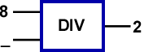

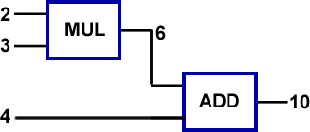
We can build more complex math machines out of the basic machines above. The equation, $2*3+4=10$ can be depicted by the two-level machine to the right. The inputs are 2, 3, and 4. The number 6 is an intermediate output with 10 being the final output.

e) Draw the two-level math machine that corresponds to the equation$, 10÷2-4= 1$.

2. Logic Machines
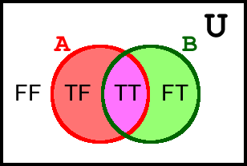
We can apply this new idea of math machines, to the Boolean concepts we explored in our previous worksheet to produce the idea of logic machines!

Let’s summarize the knowledge we built up last class that combined (John) Venn diagrams with (George) Boolean operators.

Operator | OR | NOR | AND | NAND
Venn  Diagram | 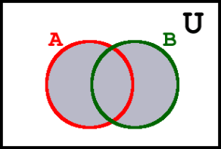 | 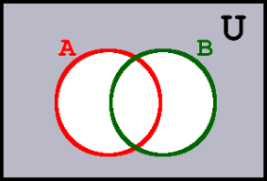 | 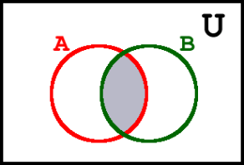 | 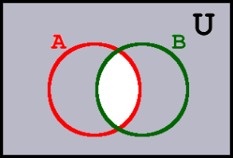
Truth  Table | OR B  F T  A F F T  T T T | NOR B  F T  A F T F  T F F | AND B  F T  A F F F  T F T | NAND B  F T  A F T T  T T F
Machine  Symbol | 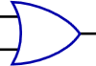 | 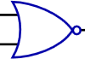 | 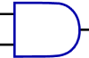

The logic machine representation of the Boolean equation, $\text{F OR T = T}$, is shown below, left. The logic machine representation of the Boolean equation, $\text{T NAND T = F}$ is shown below, right.

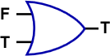 | 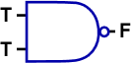

a) Complete the logic machines below.
i) | ii)  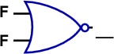 | iii)  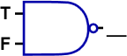 | iv)  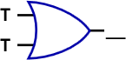

b) A three-input, two level logic machine appears below, left. For its given inputs, evaluate the final output, using D as an intermediate result. Now, as the last exercises in our fantastic introduction to computer math, summarize ALL possible results of this machine in the table below, right.
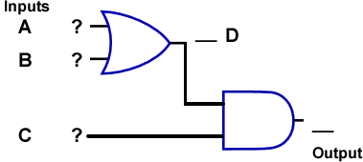 | A B D C Output  F F F  F F T  F T F  F T T  T F F  T F T  T T F  T T T

