1. Edible Numbers (aka Computer Data/Memory Sizes and Names)
In our second class we discussed the graphic below. Think deeply and see if you can answer the questions below based on your understanding of this new computer terminology.
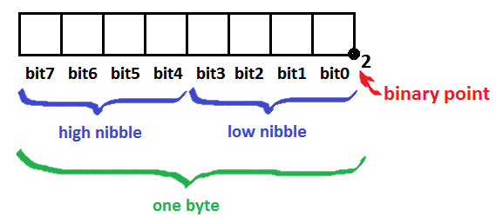

a) How many bits are there in a nibble? ________

b) How many bits are here in a byte? ________

c) How many nibbles are there in a byte? ________

d) It seems 1-, 4- and 8-bit groups have names. Suggest a name for a group of 2 bits. ________

e) Each bit can be a 0 or a 1. How many different numbers can a nibble hold? ________

f) Considering your answer to e) and knowing the smallest number a nibble can hold is zero, what must the largest number be? ________

g) Can you confirm your answer to f) in another way?

h) Write the largest binary number a byte can hold (in binary) ____________

i) What is the decimal or base 10 equivalent of your answer to h)? ________

j) What is the base 10 (decimal) equivalent of each of the following base 2 (binary) numbers?

i) 11₂ ________

ii) 111₂ ________

iii) 1111₂ ________

iv) 11111₂ ________

k) Examining your answer to j) identify a connection be the binary pattern and the decimal result.

2. Thank you! That’s Quite a Complement …
a) Write down any random decimal number to the right between 0 and 255, inclusive. _________

b) Figure out the binary equivalent of your decimal number and enter it in the byte table below.

c) Rewrite your binary number from b), reversing the digits (0’s become 1s and 1s become 0s). This number is referred to as the 1s Complement of b).

d) Add the two numbers from b) and c) and place the result in the byte table below.

e) Write down the binary number that would remain if we added 1 to the previous binary number.

f) The previous sequence of questions is of considerably significant in computing. Can you possibly imagine what it might relate to?

3. These Numbers Look a Little Shifty…
The number 3₁₀ written as a nibble-sized binary number is 0011₂ and the number 6₁₀ written as a nibble-sized binary number is 0110₂.

a) How do the bits in the binary numbers 0011₂ and 0110₂ compare?

b) Write the decimal number 12₁₀ as a nibble-sized binary number. ________₂

c) Explain two ways to get the answer to b).

d) Consider the byte-sized binary number 10011000₂. Divide this number by 8 and write it below.
_______________₂

