1. The Truth of the Matter
John Venn (1834-1923) gave us Venn Diagrams; a wonderful tool for the graphic representation of sets. His inspiration was due, in part, to his predecessor/contemporary, George Boole (1815-1864), who gave us Boolean Logic. Let’s see how these two concepts fit together…

If we replace the binary numbers, 0 and 1, with False and True respectively, or simply F and T, we can convert the previous Binary representation (below, left) into a Boolean representation (below, right).

Binary Representation | Boolean Representation
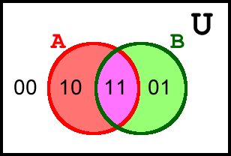 | 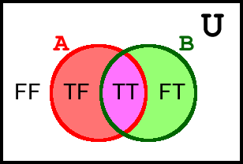

Let’s get comfortable with this new interpretation. In the Boolean representation, above right,

a) Q. How is the FF region to be interpreted?
A. A student puts his name here if his answer to the question, “Are you a Grade 5 student?” is False and his answer to the question, “Do you like Brussels sprouts?” is also False.

b) Q. How is the TF region to be interpreted?
A. A student puts his name here if his answer to the question, “Are you a Grade 5 student?” is _______ and his answer to the question, “Do you like Brussels sprouts?” is _______.

c) Q. How is the TT region to be interpreted?
A. A student puts his name here if his answer to the question, “Are you a Grade 5 student?” is _______ and his answer to the question, “Do you like Brussels sprouts?” is _______.

d) Q. How is the FT region to be interpreted?
A. A student puts his name here if his answer to the question, “Are you a Grade 5 student?” is _______ and his answer to the question, “Do you like Brussels sprouts?” is _______.

2. Turning the Tables
Just as the two binary numbers 0 and 1, led to four pairs, 00, 01, 10, and 11, the two Boolean values F and T, lead to four pairs, FF, FT, TF, TT.

In our previous worksheet we used the words OR, AND, and NOT to express the relationship between the shaded sets. Let’s look at them again…

a) | 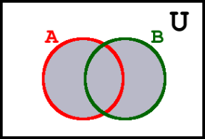 | i) Of the four pairs above right (FF, FT, TF, TT), how many fall within the shaded relationship, A OR B? 3  ii) What do these pairs have in common?  At least one T !  iii) Summarize your findings in the (truth) table to the right. | OR B  F T  A F F T  T T T
b) | 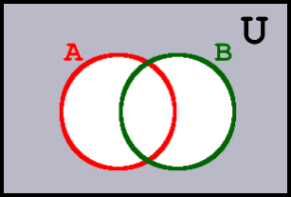 | i) Of the four pairs (FF, FT, TF, TT), how many fall within the relationship, NOT (A OR B)?  ii) What do these pairs have in common?  iii) Summarize your findings in the (truth) table to the right. | NOR B  F T  A F  T
c) | 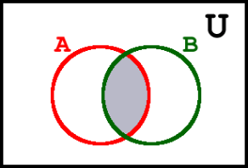 | i) Of the four pairs (FF, FT, TF, TT), how many fall within the relationship, A AND B?  ii) What do these pairs have in common?  iii) Summarize your findings in the (truth) table to the right. | AND B  F T  A F  T
d) | 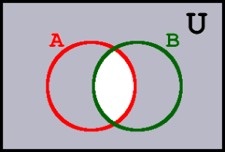 | i) Of the four pairs (FF, FT, TF, TT), how many fall within the relationship, NOT (A AND B)?  ii) What do these pairs have in common?  iii) Summarize your findings in the (truth) table to the right. | _____ B  F T  A F  T

