1. Counting Things…
What benefits do humans gain from the ability to count?

a)

b)

c)

2. Imagine a World…
Imagine if every phenomenon of our natural world was reduced to only one of two states. For example, if it wasn’t cold it would be hot. Or how about if you were not short you were tall with no in between? All people would be either young and at some point they became, instantly, old! When it wasn’t morning it would be, instantly, night. (Yikes!)

Think of four additional concepts (universally, earthly, humanly, or otherwise) that might be reduced to one of two possible states. (As strange as it might seem, computers and similar digital technology view the world in this way)

Distance
near
far

3. Imagine a (Binary) Odometer…
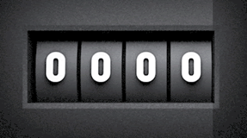
An odometer is a device we use to measure the distance travelled by a vehicle. The word derives from the Ancient Greek words hodós ("path" or "gateway") and métron ("measure"). A practical bicycle version of this device has the 10 decimal digits etched onto the four cylindrical wheels, however, for this thought experiment, you are to imagine that it counts the distance in binary!

a) For the binary odometer, how many digits are etched onto each of the four wheels?

b) How many 4-digit numbers can the odometer display?

c) What would the odometer display after you had traveled?

i) 2 km?

ii) 3 km?

iii) 7 km?

c) How far would you have travelled just before the odometer rolls over to 0000 again? km

d) Imagine a custom version of this odometer in which you could add additional wheels.

i) Add a 5th cylindrical wheel. How far could you ride before the display rolls over? km

ii) Add a 6th cylindrical wheel. How far could you ride before the display rolls over? km

iii) Add a 7th cylindrical wheel. How far could you ride before the display rolls over? km

iv) Finally, add an 8th cylindrical wheel. How far could you ride before the display rolls over? km

4. Different Number Systems…
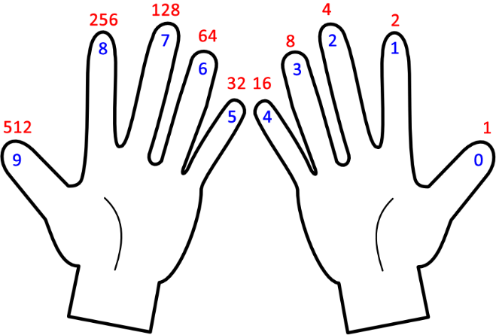
As a result of the concept of place value, numbers of equal value are expressed differently in various bases. Numbers relating to computer concepts are more easily written in bases that are powers of 2, such as 2 (binary), 8 (octal) and 16 (hexadecimal). Complete all the missing entries in the table below…

Binary  Base 2 | Octal  (Base 8) | Decimal  (Base 10) | Hexadecimal  (Base 16)
0000. | 00. | 00. | 00.
0001. | 01. | 01. | 01.
0010. | 02. | . | 02.
0011. | . | . | 03.
. | 04. | . | .
. | 05. | . | .
. | . | . | .
. | 07. | . | .
. | 10. | . | .
. | 11. | . | .
. | . | 10. | .
1011. | . | 11. | .
. | . | . | 0C.
. | . | . | 0D.
. | 16. | . | .
. | . | . | .
. | . | . | 10.

5. Really Difficult (Binary) Odometer Question…
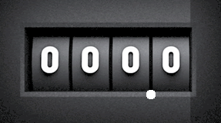
OK, you’ve heard of a decimal point and you likely know what its purpose is. The modified binary odometer has a binary point between the two rightmost binary digits. If you had one of these mounted on your handlebars, how far would you have ridden when the odometer displays 111.1?

Answer: _________km

