1. Adding to Your Knowledge…
a) Perform the following additions on two nibbles using binary (Base 2) numbers…

i) ii)
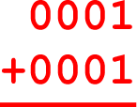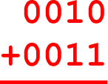

iii) iv)

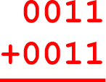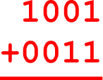

v) vi)

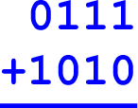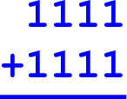

b) Confirm you answers above by converting all the numbers to decimal (Base 10).

c) Did any of the previous additions overflow the nibble-size (4-bit) capacity allotted for the sum?

2. Logically Speaking…
a) Venn diagrams (named after John Venn, 1834-1923) developed a graphic method for demonstrating logical relationships. These diagrams are very useful for explaining how computers work, as you will eventually see. In the meantime, let’s practice.

i) The rectangle U stands for the Universal set of ALL RSGC students. Write your name in rectangle if you are a member of this universe. Who, in the room, does not write their name in the rectangle? | ii) The red circle, A, is the set of all students in Grade 5. Why is this set completely contained with the rectangle? Write your name within the rectangle at a location that reflects your place within our universe.  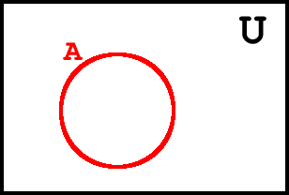
iii) The set B represents students that like Brussels sprouts. Write your name within the rectangle that best reflects your place within our universe.  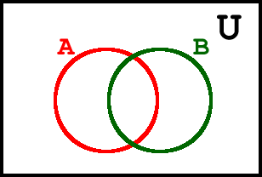 | iv) The set C represents students that play Chess, regularly. Write your name within the rectangle best reflects your place within our universe.  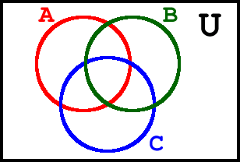

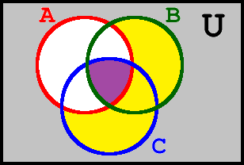
b) Using words like and, or, and not, explain who would write their names in the coloured regions listed below.

i) yellow
ii) purple
iii) gray

