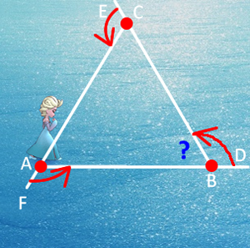
1. How do we know the sum of the interior angles of a triangle is 180°? Let’s find out…

a) First we’ll set the conditions for this analysis.

i) We will assume that one full rotation is 360°

ii) In the equilateral triangle ABC to the right, each of the sides has been extended to a remote point.

iii) Elsa starts at vertex A, and faces east.

iv) Anna skates clockwise around the triangle before returning to her starting position.

b) Let’s answer these questions after Anna skates the triangle ABC once.

i) What is the total degree measure of Anna’s turns? _________

ii) How many turns does Anna make? _________

iii) Are all these turns of equal measure? _________

iv) What is the degree measure of each of the angles marked in red? _________

v) What is the degree measure of ∠ABC? _________

vi) Are each of the interior angles of equal measure? _________

vii) What is the total of the three interior degree measures? _________

2. What is the total measure of the interior angles of a square? ________  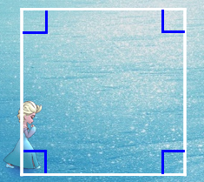 | 3. What is the total measure of the interior angles of a pentagon? ________  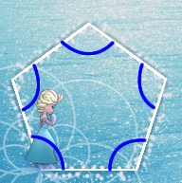

4. What is the total measure of the interior angles of an hexagon? ________  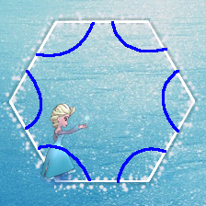 | 5. What is the total measure of the interior angles of a octagon? ________  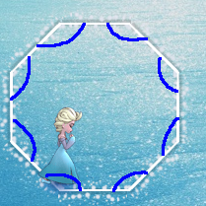
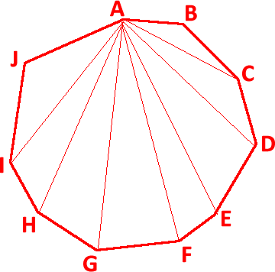
6. A 10-sided irregular polygon (decagon) appears to the right.

Starting from vertex A, we can construct 8 interior triangles by connecting A to non-neighbouring vertices.

a) What is the sum of the interior angles of the decagon?

________________________

b) Imagine we had a polygon with n sides. How many interior triangles could we draw?__________________

c) What is the total interior degree measure of polygon with n sides?__________________
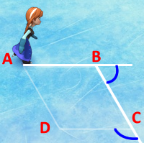
7. In our Hour of Code’s Challenge 10, Anna is required to skate a parallelogram.

a) Use your reasoning skills; identify the measure of the exterior angle at B.

b) Use your reasoning skills; identify the measure of the exterior angle at C.

c) What do you think the code would be to successfully skate the parallelogram?

