Let’s work through the following sequence to prepare ourselves for analyzing the 5-Pointed Star.

1. Identify the measure of ∠ B  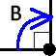 | 2. .Identify the measure of ∠ A.  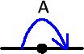 | 3. Identify the measure of ∠ C.  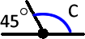
4. Identify the measure of ∠ D.  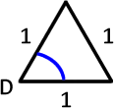 | 5. Identify the measure of ∠ E.  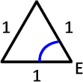 | 6. What is the total measure of the interior angles of equilateral triangle DEF?  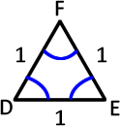
7. Identify the measure of ∠ G.  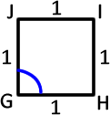 | 8. Identify the measure of ∠ H.  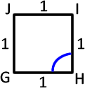 | 9. What is the total measure of the interior angles of the square GHIJ?  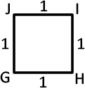
1. The TOTAL measure of the interior angles of a polygon with n sides is 180*(n-2).
Does this result agree with your answers to Questions 6 and 9 above?
2. If the lengths of all sides of a polygon ere equal then the all the interior angles are equal, too!
We call this type of polygon a regular polygon!
10. What is the total measure of all the interior angles of the 5-sided pentagon KLMNO?  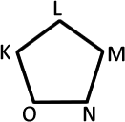 | 11. Identify the measure of ∠ K.  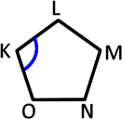 | 12. Identify the measure of the indicated angle.  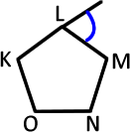

We now have enough understanding of regular polygons to analyze the 5-Pointed Star.

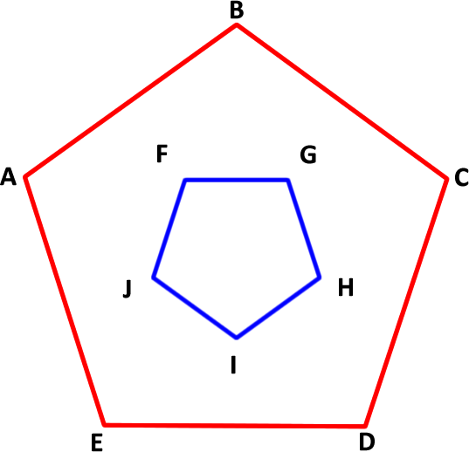
13. Consider the inner and outer regular pentagons to the right.

a) What is the measure of ∠ JFG?

b) Draw a straight line from B to F.

c) What is the measure of ∠ BFG?

d) Draw a straight line from B to G.

e) What is the measure of ∠ FGB?

f) What is the measure of ∠ GBF?

g) Draw the remaining lines to create the five-pointed star?

14. a) As you know, each of the 20 scenarios in this Frozen Coding Environment asks you to complete a specific task.

b) For each task, the programming statements you can choose from are limited to those that you would need to be successful.

c) We’re trying to complete a task of our own design!

d) I was only able to find one(!) scenario that offered the necessary programming statements to complete our 5-Pointed Star.

Final Task

15. Select Step 17 and, based on our previous analysis, see if you can develop the code necessary to produce a 5-Pointer Star as shown above right.

