1. Examine the code below left. When skated, the path is a familiar car logo! Anna is initially facing south. See if you can trace Anna’s path to identify the logo.

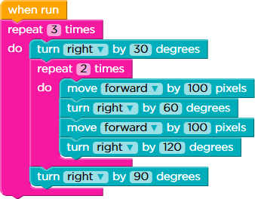 | 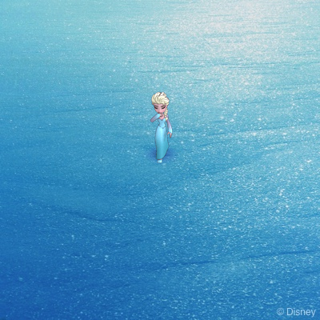

2. The code below is from Challenge 13. Can you suggest the correct replacement for ??? that is required to complete the circle on the right?

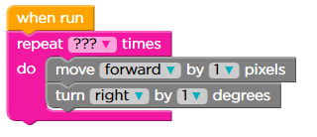 | 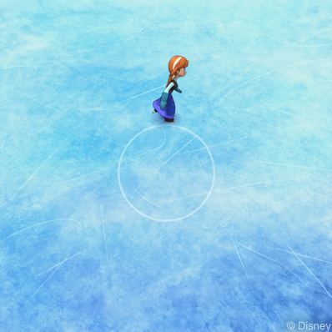

3. The code below right does not produce a visual result of great interest. What we need to know is how many times each of the actions are undertaken! Fill in the answers for each of the following questions.
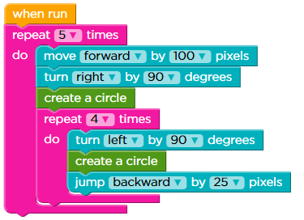
a) How many times does Anna move forward?

b) How many times does Anna turn right?

c) How many times does Anna turn left?

d) How many times does Anna move backwards?

e) How many times does Anna jump backwards?

f) How many circles does Anna skate?

4. The code below left is taken from a successful solution to one of the Challenges. Can you interpret the code and explain what it does? Which Challenge does this come from?

1. for (var i = 0; i < 20; i++)  2. {  3.  4. // create_a_circle  5. for (var j = 0; j < 36; j++) {  6. moveForward(10);  7. turnRight(10);  8. }  9.  10. jumpForward(50);  11. turnRight(18);  12. } | 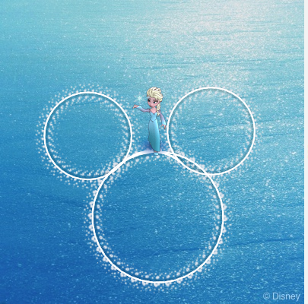
5. Given the Disney theme we’re coding in, use the statements in Challenge 20 to create an image of Mickey Mouse as I’ve tried to do above right.

