1. Follow the Headings link from our course page to recreate result below left using heading tags <h1> through <h6>.

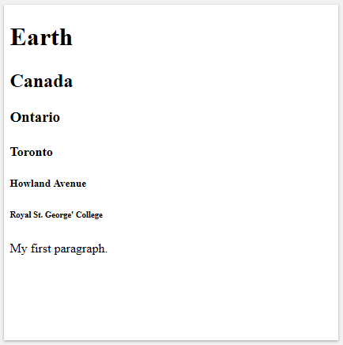 | 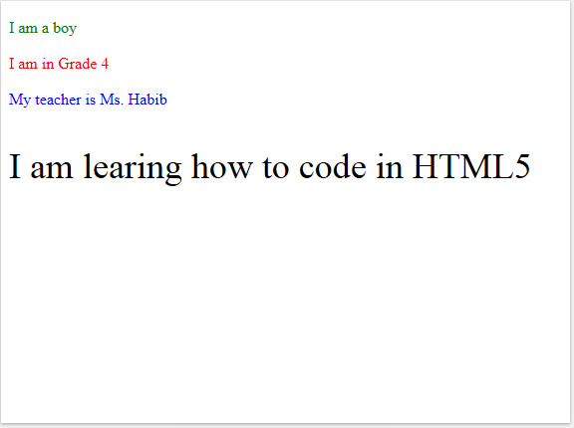

2. Follow the Colour link from our course page to recreate the result above right.

3. Follow the Links link from our course page to create the result below left.

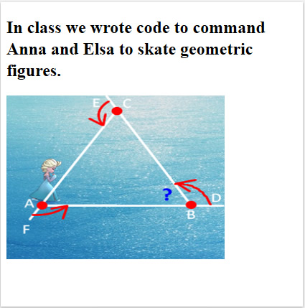

4. Follow the Images link from our course page to create the result above right.

5. Create a web page on a subject that interests you using the four tags above.

