Use this page to submit a proposal for your Independent Study Project. You have read the underlying philosophy of the activity (http://darcy.rsgc.on.ca/ACES/ISPs/Hardware.html), explored various topics of pursuit and have understood the assessment criteria (http://darcy.rsgc.on.ca/ACES/ISPs/ISPEvaluation.docx).

1. Your Name:

2. Project Title:

3. Provide a brief description of the project:

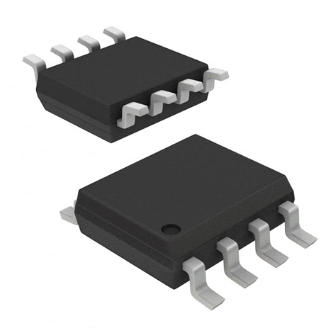
4. Provide specific digikey SMD part descriptions
(https://www.digikey.ca/)
My commitment to you is to provide you with the SMD components you require for your ISP. For this I need the most accurate list of Digikey parts data possible. Add, edit or remove the respective parts below.
Part | Package | # | Digikey Part Number | Comments
AVR uC? | eg. 8-SOIC | 1 | ATTINY85-20SU-ND
Shift Register | 16-SOIC | 1 | 296-4618-5-ND
USB Micro B |  | 1 | 609-4613-1-ND
Passive | 1206 | 1
Passive | 1206
Passive | 1206
FFC |  | 1 | WM10537-ND
FFC Connector |  | 1 | WM10939CT-ND
LED (RG) | 1206 |  | 160-2026-2-ND
SMD 7-SegDis |  |  | 516-3011-1-ND
Momentary PB |  |  | CKN9104CT-ND
555? | 8-SOIC |  | LM555CMXFSCT-ND
4511?

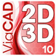
5. Provide additional SLIM CAD case details (Staple sketch if necessary)

NOTE: Be sure to check ALL the applicable boxes on the reverse.

Please check all boxes corresponding to the concepts and skills you intend to exploit in this project.
Hardware Components | Software Techniques | Power | Skills
□ resistors  □ capacitors  □ potentiometers  □ transistors  □ diodes  □ push buttons  □ switches  □ LDRs  □ thermistor  □ temperature sensor  □ proximity sensor  □ IR (infrared)  □ Radio Frequency (RF)  □ Bluetooth  □ OpAmps  □ voltage regulators  □ MOSFETs  □ surface mount parts  □ Logic ICs (40xx)  □ shift registers  □ Specialty ICs (555,MSGEQ7, H-Bridge, LM3914, etc.)  □ Real Time Clock (RTC)  □ ATtiny85  □ LEDs (single, Bi, RGB)  □ 7-segment display  □ Alphanumeric display  □ Bargraph  □ LED Matrix  □ LCD Panel  □ Graphics Panel  □ DC motor  □ servo motor  □ stepper motor  □ solenoid  □ microphone  □ audio line in  □ speaker  □ magnets  □ point-to-point board  □ perma-proto board  □ custom PCB  □ OTHER | □ High-Level  □ Assembly  □ Arrays  □ Structs  □ bitwise operators  □ I²C (TWI)  □ Libraries  □ ADC  □ PWM  □ Serial Comm. (ISP)  □ Debouncing  □ LookUp Table  □ Polling  □ Persistence of Vision  □ Interrupts  □ Recursion  □ ISP  □ EEPROM  □ Processing  □ Charlieplexing  □ Timing related  □ UML Design  □ OTHER | □ Batteries  □ AC/DC Adapter  □ Transformers  □ coils/chokes  □ 12V  □ 24V  □ solar  □ manual  □ Peltier tiles  □ OTHER | □ reading a schematic  □ through hole soldering  □ surface mount soldering  □ printed circuit board layout and manufacturing  □ DMM Debugging  CAD  □ 3D printing  □ acrylic fabrication  Word  □ Excel  □ Time-management  □ Fritzing  □ Presentation Overview  video creation  technical writing  □ OTHER
 |  |  | Engineering Fields
□ electrical
□ computer
□ mechanical
□ software
□ OTHER

