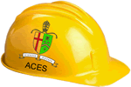
Use this page to submit a proposal for your Independent Study Project. You have read the underlying philosophy of the activity (http://darcy.rsgc.on.ca/ACES/ISPs/Hardware.html), explored various topics of pursuit and have understood the assessment criteria (http://darcy.rsgc.on.ca/ACES/ISPs/ISPEvaluation.docx).

1. Your Name: 2. Project Title:

3. Provide a brief description of your project within each of the three domains.

Hardware:

Software:

Design:

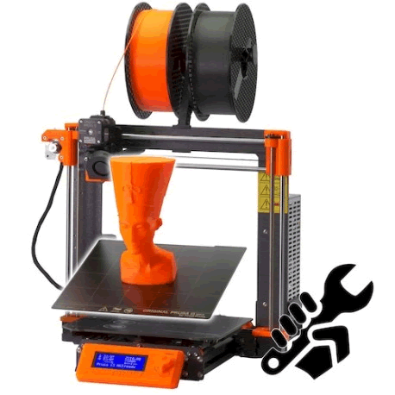
4. Why did you select this project?

Please check all boxes corresponding to the concepts and skills you intend to exploit in this project.
Hardware Components | Software Techniques | Power | Skills
□ resistors  □ capacitors  □ potentiometers  □ transistors  □ diodes  □ push buttons  □ switches  □ LDRs  □ thermistor  □ temperature sensor  □ proximity sensor  □ IR (infrared)  □ Radio Frequency (RF)  □ Bluetooth  □ OpAmps  □ voltage regulators  □ MOSFETs  □ surface mount parts  □ Logic ICs (40xx)  □ shift registers  □ Specialty ICs (555,MSGEQ7, H-Bridge, LM3914, etc.)  □ Real Time Clock (RTC)  □ ATtiny85  □ LEDs (single, Bi, RGB)  □ 7-segment display  □ Alphanumeric display  □ Bargraph  □ LED Matrix  □ LCD Panel  □ Graphics Panel  □ DC motor  □ servo motor  □ stepper motor  □ solenoid  □ microphone  □ audio line in  □ speaker  □ magnets  □ perma-proto board  □ custom PCB  □ OTHER | □ High-Level  □ Assembly  □ Arrays  □ Structs  □ bitwise operators  □ I²C (TWI)  □ Libraries  □ ADC  □ PWM  □ Serial Comm. (ISP)  □ Debouncing  □ LookUp Table  □ Polling  □ Persistence of Vision  □ Interrupts  □ Recursion  □ ISP  □ EEPROM  □ Processing  □ Charlieplexing  □ Timing related  □ UML Design  □ OTHER | □ Batteries  □ AC/DC Adapter  □ Transformers  □ coils/chokes  □ 12V  □ 24V  □ solar  □ manual  □ Peltier tiles  □ OTHER | □ reading a schematic  □ through hole soldering  □ surface mount soldering  □ printed circuit board layout and manufacturing  □ DMM Debugging  CAD  □ 3D printing  □ acrylic fabrication  Word  □ Excel  □ Time-management  □ Fritzing  □ Presentation Overview  video creation  technical writing  □ OTHER
 |  | Design Tools | Engineering Fields
 |  | □ ViaCAD  □ Fusion  □ 3D Print  □ Laser Acrylic  □ PCB (Eagle)  □ PCB (Other)  □ OTHER | □ electrical  □ computer  □ mechanical  □ software  □ OTHER

