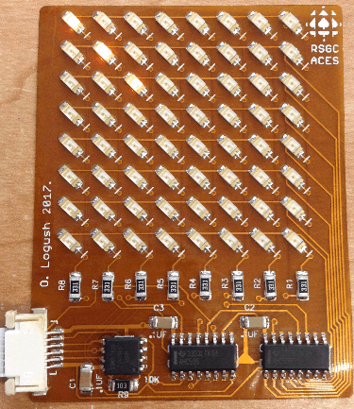
Use this page for your Flexible Circuit Project proposal that will result in a circuit embedded into the context of a double-sided Word page. This page will be your final DER entry and bound in time for presentation at your graduation. In completing this project, you will enhance and showcase your skills in manipulating surface mount technology, solidify your mid- to low-level microcontroller coding skills and demonstrate your creativity. Be sure to consult with our ACES_SMT.lbr EAGLE Library for the available parts. View Jackson Russett’s (ACES ‘16) summary video of his submission: https://www.youtube.com/watch?v=oGgDkF77RqA . As well, view Oliver Logush’s (ACES’18) ‘Charlie’flexed Matrix he produced in 2017 as a Grade 11 ACE: https://www.youtube.com/watch?v=qTdoXipdXz4

1. Your Name

2. Project Title

3. Project Description

4. Power (Highlight One)
3.6V 100mA Flexible Solar Film (Video) | Coin | Induction | External | Other?

5. Processor (Highlight One)
ATtiny84 (SOIC-14) | ATtiny85 (SOIC-8) | ATmega328p(TQFP-32) | Other?

6. Language (Highlight One)
AVR Assembly in AS7 | Arduino IDE C/C++ | Other?

7. ISP Strategy (Highlight One)
Soldered Connector | Custom ISP ‘Finger’ | Other?

8. Unusual, (Non-Stocked) Components (include Digikey Links)

9. Additional Comments (you think i should be aware of)

