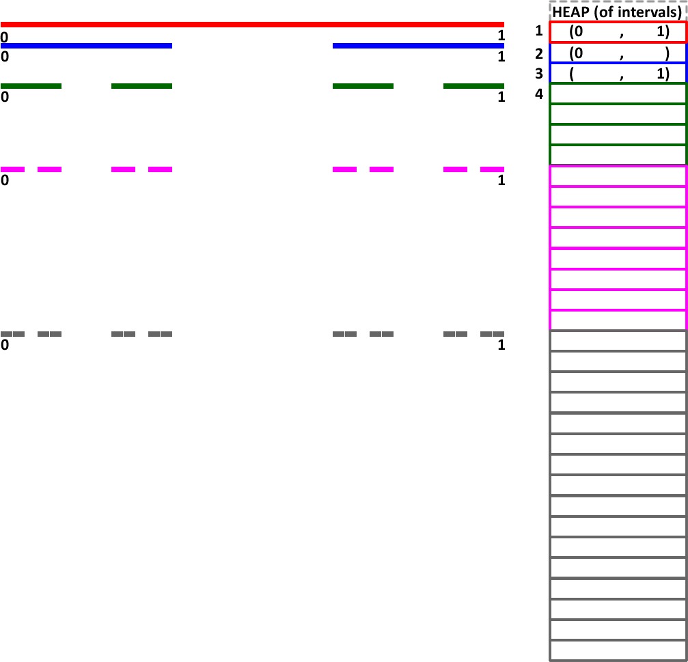
The Cantor Set
The graphic to the right is an attempt to depict the first few stages in the propagation of the ternary Cantor Set. Starting with a line of unit length (initiator), the open middle third is removed (generator). This process is repeated at every stage for each line remaining segment.
1. The Cantor Set evolves as a Binary Tree.
a) Given there is one segment at Stage 0, how many segments are there at Stage n?
b) How many total segments are there after n stages?
2. Given the set is based on the removal of thirds, it is reasonable to define the unmarked endpoints of each segment in base 3. Do so.
3. The array that appears to the right of the depiction can be used to record the intervals. Complete as many intervals as it takes for you to identify a pattern.
4. Suggest a strategy for O(1) access to the intervals corresponding to the n’th stage.

