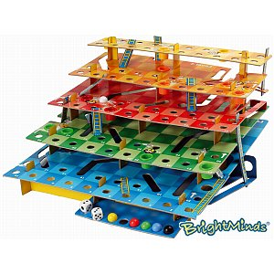
Instruction to Students
- This exam contributes 30% towards your final mark.
- Appropriate coding and documentation styles are expected.
- You are allowed access to your former project files on your laptop.
- Internet access is available for the purpose of viewing the animation and consulting Robots online documentation if needed.
- You are to take the first 10 minutes to read this exam over, understand the expectations and plan your solution, after which you will be given permission to open your laptops, continue planning and, finally, coding.

Snakes and Ladders
As much as we would all enjoy a 3D version of Robots the 2D will work just fine for this project.

H
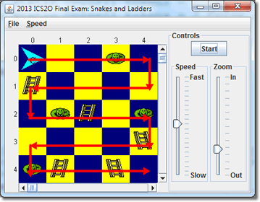
istory attributes Snakes and Ladders to an ancient board game from India. Players take turns advancing their tokens based on a roll of a die with the object of being the first to land exactly on the final square.

In our version of the game, the board is a 5×5 square with players starting at (0, 0) and finishing exactly at (4, 4). Players normally travel east along even-numbered streets and west along odd-numbered streets. The only exception to this is if the token is relocating after landing on either a snake or a ladder.
Specifically, at the end of a roll, if a player’s token lands on a square occupied by either a snake or a ladder, the token immediately relocates to a square determined by the number of snakes or ladders on the intersection. Snakes result in relocation closer to the finish; ladders closer to the start.

Unzip SnakesAndLadders.zip to a folder on your Desktop and click SnakesAndLadders.jar to view the action as many times as you like. Speed it up and slow it down as necessary to get a good understanding of the behaviour of the player before you undertake your own Stepwise Refinement design strategy. You will find the zip file at:

http://darcy.rsgc.on.ca/ACES/ICS2O/Exams/SnakesAndLadders.zip.

The complete UML for this project appears below. The blue classes are provided by the becker.jar file and the red classes are available within SnakesAndLadders.jar file. The driver class is appears in green and the source code for this class is provided which you are expected to use. This leaves the Player class in orange for you to implement.

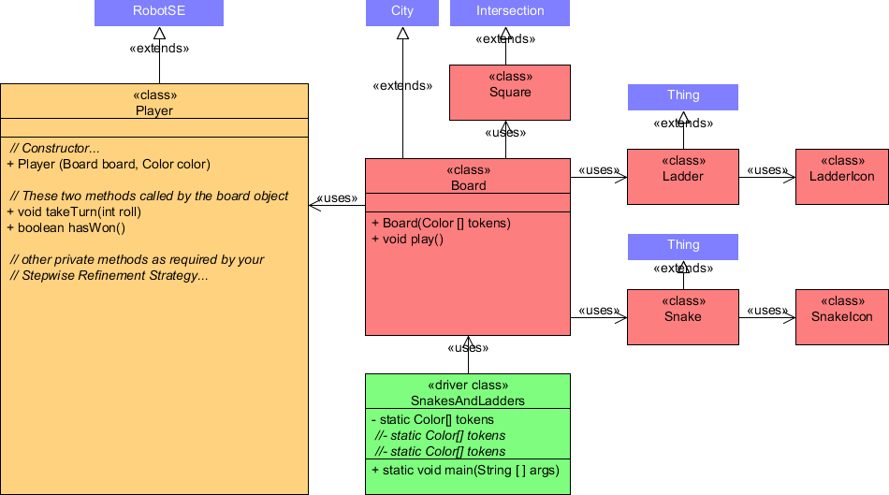

The project documentation can be reviewed at this URL,
http://darcy.rsgc.on.ca/ACES/ICS2O/Exams/SnakesAndLadders/doc/index.html

Implementation Overview and Specifics
The driver instantiates a Board object and calls its play() method to undertake a game of Snakes and Ladders. Play continues until a Player object ends a turn on (4, 4) at which point the Board object labels it the Winner!and the game is over. The cyan-coloured token labeled C is the computer. He always plays. Additional players, with colours defined by the tokens array can play if you so desire. The Board object is responsible for determining the order of play by calling each Player’s takeTurn method, in sequence, passing it a random value between 1 and 6 inclusive. After each turn, the Board object will call the Player’s hasWon() method. If this method returns true, the game ends.

The Player constructor should ensure each player starts the game at (0,0), faces east, and appears in color specified (the Board object will label the computer C; other players do not have labels). The takeTurn(int roll) method ensures the object can move (since it can never leave the board it doesn’t move if a roll would put it beyond the finish square). Once it moves (west to east on even-numbered streets; east to west on odd-numbered streets) if it comes to rest on a square inhabited by a snake or ladder, it immediately relocates to an intersection defined by the tens and units digits of the count. For example, if a Player lands on a square occupied by 34 snakes (or ladders), it immediately relocates to (3, 4) before finishing its turn. The hasWon() method simply returns true if the Player finishes a turn on (4,4), false otherwise.

Task

- Read this exam and related documentation thoroughly.
- Create a SnakesAndLadders project, download and unzip the SnakesAndLadders.zip file and set up the project in the manner for which you have become accustomed.
- Run the simulation as often as necessary to understand the action, fully. The cyan-colored Player object (with C as its label) is the computer. He always plays.
- The default driver file SnakesAndLadders.java consists of one of three tokens arrays of Color objects. As you can see this is the only argument passed to the Board constructor. The null tokens array is interpreted by the Board object to undertake a game with only the computer playing. Activating either of the other two tokens arrays plays a game with additional players represented by the indicated colours.
- Develop only the source code for the Player class.
- Using the appropriate syntax, document your source code, fully.
- In the last 10 minutes, attach Player.java to an email to handin under the Subject Line, SnakesAndLadders.

Evaluation

The focus of our introduction to Java this term was the creation of well-named, well-designed, robust, single-purpose methods that reflect the problem-solving skills of the author who has broken a large task into manageable, bite-sized pieces. The highest marks then will be reserved for those students that submit a class that,

- (5) Design. Reflects sound, well-thought-out Stepwise Refinement strategies
- (5) Documentation. Superior documentation styles and content.
- (5) Efficiency. No unnecessary statements.
- (15) Accuracy. Functions exactly as required by the examination specification.

Enjoy a safe and enlightening summer and,
if you are continuing on in our ACES program,
don’t forget anything you’ve been taught. (you’ll need it!)

