
Instruction to Students
- This exam contributes 30% towards your final mark.
- Appropriate coding and documentation styles are expected.
- You are allowed access to your former project files on your laptop.
- Internet access is available for the sole purpose of viewing the animation and consulting Robots online documentation if needed.
- You are to take the first 10 minutes to read this exam over, understand the expectations and plan your solution, after which you will be given permission to open your laptops and start coding.

2012 London Olympics: The Staggered Hurdles

The Staggered Hurdles is a demonstration event for the 2012 London Olympics. Each competitor (an instance of the Runnable Athlete Class) begins on the starting line (Avenue 0) and must make his way to the finish line (Avenue 21). In between, each competitor is required to jump over 5 hurdles, placed at random positions between Avenue 3 and Avenue 19, inclusive. Athletes from China, England, USA, Canada, Jamaica and Germany have qualified for the final. Their country’s flag appears as their icon, on top of which is placed a randomly-generated two-digit label. Here is the scene, moments before the start of the race. Unzip London.zip to your Desktop and click London.jar to view the action. You find it at: http://darcy.rsgc.on.ca/ACES/ICS2O/Exams/London.zip

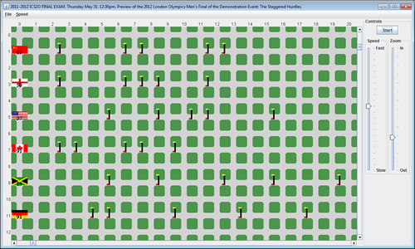
The UML for the London Project appears below. The blue classes are readily available and the red files are provided. This leaves the orange files you to implement.

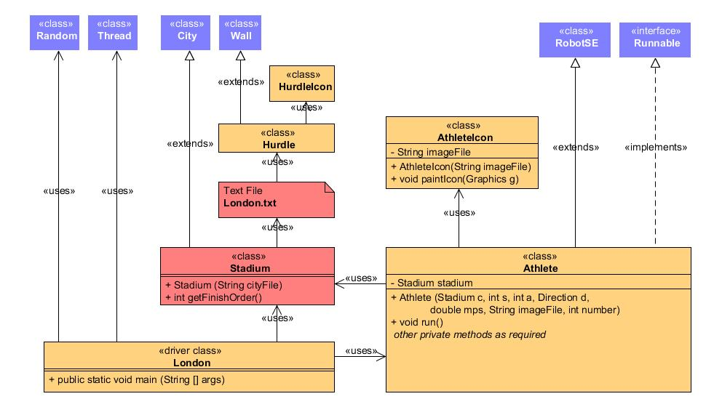

The project documentation can be reviewed at this URL,

http://darcy.rsgc.on.ca/ACES/ICS2O/Exams/London/doc/index.html

Task
- Read this exam and documentation thoroughly. Run the simulation as often as necessary.
- Create a project called London and add the seven .gif files to the root folder.
- Add the source file Stadium.java to the src file of the project.
- Do NOT add the London.jar file to your project.
- Develop implementations for the five orange coloured classes in the UML above .
- Using the appropriate syntax, document your ALL source code.
- In the last 10 minutes, attach the source code for the 5 orange files above to an email to handin under the subject line, London.

Evaluation
The focus of our introduction to Java this term was the creation of well-named, robust, single-purpose methods that reflect the problem-solving skills of the author who has broken a large task into manageable, bite-sized pieces. The highest marks then, will be reserved for those students that submit a classes that,
- (5) Design. Reflects sound, well-thought-out stepwise refinement strategies
- (5) Documentation. superior documentation styles and content .
- (5) Efficiency. No unnecessary statements.
- (15) Accuracy. Functions exactly as required by the examination specification.

