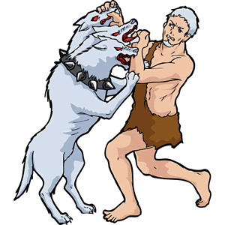
Instruction to Students
- This exam represents 30% of your final mark.
- Appropriate coding and documentation styles are expected.
- You are allowed access to your former project files on your laptop.
- Internet access is available for the sole purpose of viewing the animation and consulting Robots online documentation if needed.
- You are to take the first 10 minutes to read this exam over, understand the expectations and plan your solution, after which you will be given permission to open your laptops and start coding.

Three Labours of Hercules
Mythology has it that in order for Hercules find redemption, the Greek gods commanded him to perform twelve near-impossible labours. Hercules was given twelve years to accomplish the feats but since you only have two hours, your not-so-impossible labours are limited to three. Here’s how the project works.

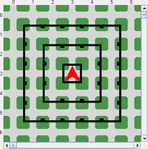
hercules (an instance of the Hero class) starts the simulation inside a concentric nest of three completely-walled squares (Figure 1). The gods (an instance of the Gods class) command hercules by invoking Hero methods. You have access to Gods.class, but just as the gods were never seen by mortals you, too, do not have access to the source code for Gods.java (just the bytecode file, Gods.class). Your task is to trust that the gods know what they’re doing and simply complete each of the bodies of the required Hero methods. As you do, the gods will turn one of the walls in the square gray and give hercules the power to walk through it. An additional magical power the gods empower hercules with is the ability to walk through all of the walls of the square layers he has previously escaped from. Images of the completed labours hercules must undertake appear below. Labour One is simply to place a Thing at the location hercules starts at. Labour Two requires that he places a single Thing at each of the four indicated locations. Labour Three requires that hercules leave a Gold (red: 206; green 160: blue:8) Thing with a reduced size of 0.25 at the indicated location. Note that hercules only has 6 Things in his backpack at the start.
Figure 1. Start of Labours

Labour One | Labour Two | Labour Three
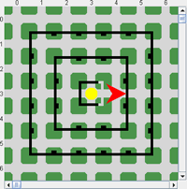 | 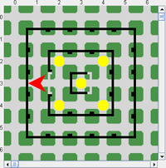 | 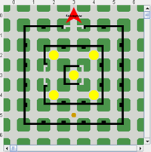

A simulation of Three Labours of Hercules can be found at,

http://darcy.rsgc.on.ca/ACES/ICS2O/Exams/2011RobotsExamLabours.html
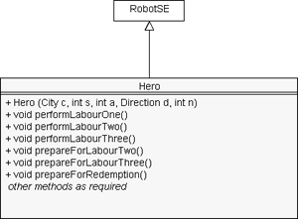

As stated on the previous page, your task is to develop the source code for the Hero class defined by the adjacent UML diagram. The public methods, including the constructor, are invoked by the gods.

For further information on the purpose of each of the public methods consult the javadoc for the Hero class at the URL,

http://darcy.rsgc.on.ca/ACES/ICS2O/Exams/Hero/Hero.html

Task
- Read this exam thoroughly. Consult the simulation and documentation as often as necessary.
- Create a project called Labours, and drop the driver file Labours.java and the bytecode file Gods.class (extension of City) into their respective folders. (these files can be obtained from our subject conference 10 minutes after the start of the exam)
- Develop an implementation of the Hero class and any private methods your stepwise refinement strategies suggest according to the UML diagram above.
- Fully document your Hero source code.
- In the last 10 minutes, attach Hero.java to an email handin under the subject line, Three Labours of Hercules.

Evaluation
The focus of our introduction to Java this term was not about the use of complex methods, or fancy-looking icons (although we dabbled in both), but rather the creation of well-named, robust, single-purpose methods that reflect the problem-solving skills of the author who has broken a large task into manageable, bite-sized pieces. The highest marks then, will be reserved for those students that submit a Hero class that,

- reflects sound, well-thought-out stepwise refinement strategies
- superior documentation styles and content
- efficiency, and,
- follows exactly and complete all aspects of this examination

