2019/2020 RSGC ACES Program

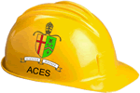
The ACES program was initiated in 2003 to address RSGC’s moral obligation to develop each Georgian’s unique talent set within the multidisciplinary design, software, hardware and technical writing domains. Our philosophy is based on the confidence that these assets bolster the quality of one’s life through the cultivation of deep thinking and problem-solving skills. Our current physical space hosts a hands-on technical curriculum in the form of a sequence of three courses designed to prepare design and engineering-minded Georgians for the future that we envision. Please tour our website to explore the past and present manifestations of our philosophy.
ICS2O-E ⎯ DC Circuits (10) This hands-on half-course builds on the Science 9 introduction to Electricity. Students work their way through concepts in and analog and digital circuitry employing curriculum designed specifically for our RSGC ACES program. Topics include reading schematics, prototyping, semiconductors, integrated circuits, as well as safety, environmental, and societal awareness. This course provides the foundation for our subsequent ICS3U-E AVR Foundations course. Detailed reports on projects develop strong technical writing and formatting skills.

ICS4U-E ⎯ AVR Optimization (12) ICS3U-E graduates are now prepared to explore the deepest level computer architecture from a homebrew, 4-bit TTL-based processor to 8-bit AVR microcontrollers. Only through the knowledge, skill, and application of assembly language instructions can these devices be truly optimized for performance. In addition to common core curriculum, students undertake three Independent Study Projects (ISPs) on areas of interest to them, thereby affirming and solidifying their individual passions and skill sets enabling them to make well-informed, university-related decisions.
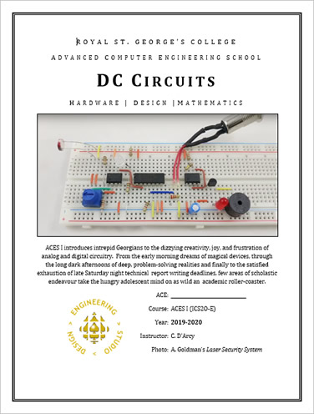
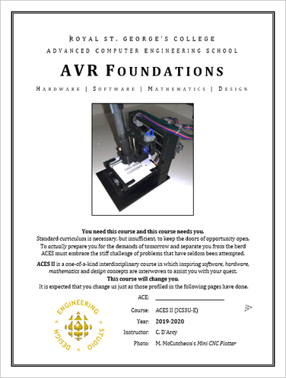
ICS3U-E ⎯ AVR Foundations (11) Students are introduced to the architecture and implementation of microcontroller applications using the AVR family of microcontrollers. Topics include analog and digital concepts including the binary number system, ADC and DAC, PWM and interrupts. Printed Circuit Board layout and CAD/CAM skills are introduced enabling complete prototyping of projects based on light, sound, temperature, distance, mechanics, pressure, and power. Detailed reports on projects maintain strong technical writing and formatting skills.

University Placement in Computer, Electrical, Mechanical or Software Engineering

A Focus on Skills

RSGC’s three-year ACES program provides students with a unique set of practical skills that are developed in parallel with the acquisition of theory and knowledge of electrical, computer and software engineering concepts. It is only through the pursuit of working prototypes that assumptions can be fully challenged, oversights exposed and the unforeseen and unexpected behaviour of so-called ‘ideal’ components be tested. Furthermore, by the time students get to university, with their emphasis on theory-heavy curriculum, students (and their group partners!) will appreciate the advantage of a practical foundation in this domain.

Finally, potential employers are looking for candidates that go beyond a high GPA and can actually demonstrate their knowledge through the creation of physical prototypes.

Below is a partial list of skills introduced in each of our ACES’ courses.

Grade 10 (ICS2O-E)
1. Design Tools I (Fritzing)
2. Reading and Creating Schematic Diagrams
3. Breadboarding a Prototype
4. Troubleshooting (Debugging) Circuits
5. Design Tools II (EAGLE)
6. Using a Digital Multimeter
7. Through-Hole Soldering
8. Testing a Transistor
9. Technical Writing Skills
10. Advanced Word and Excel Techniques
11. Technical Presentations Skills
12. Time-Management Skills Involving Suppliers and Couriers

Grade 11 (ICS3U-E)
13. Computer-Assisted Drawing (ViaCAD)
14. Printed Circuit Board (PCB) Layout Design (EAGLE)
15. PCB Ordering and Fabrication
16. Arduino/C Programming
17. 3D Printing and Vacuum Forming Skills I
18. Online Database Search Techniques and Parts Ordering
19. Global Awareness and Outsourcing of PCB Manufacturing and Ordering

Grade 12 (ICS4U-E)
20. Surface Mount Soldering
21. ATMEL Assembly Language Programming
22. 3D Printing and Vacuum Forming Skills II
23. Building a Processor from TTL Chips
24. Teaching, Mentoring, and Technical Support for Younger ACES and DES Users

