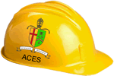
2017/2018 RSGC ACES Program

It is the belief of the RSGC ACES program that the majority of the leaders of tomorrow will emerge from the ranks of the creators and doers. To support our philosophy, we offer a sequence of three courses designed to prepare engineering-minded Georgians for the future that we envision. Our curriculum can aptly be described as problem immersion with an emphasis on project-based solutions and skill development. Students engage continuously in problem-solving contexts with the primary aim of developing deeper technical thinkers. Design and communication technologies are fully integrated into the engineering technology process to produce remarkably comprehensive outcomes. Please tour our website to see the manifestation of our philosophy.
TEL3M ⎯ Circuits 10. This hands-on half-course builds on the Science 9 introduction to Electricity. Students work their way through concepts in and analog and digital circuitry employing curriculum designed specifically for our RSGC ACES program. Topics include reading schematics, prototyping, semiconductors, integrated circuits, c as well as safety, environmental, and societal awareness. This course provides the foundation for our subsequent TEI3M Microcontrollers 11 course.

University Placement in Computer, Electrical, Mechanical or Software Engineering Mathematics, or Science
TEI4M ⎯ Computer Architecture. TEI3M graduates are ready to explore the deepest level computer architecture from a homebrew, 4-bit TTL-based processor to 8-bit AVR microcontrollers. Only through the knowledge and application of assembly language instructions can these devices be truly optimized for performance. In addition to common core curriculum, students undertake three Independent Study Projects (ISPs) thereby developing and affirming their unique passions and skill sets enabling them to make informed university-related decisions.
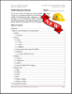
TEI3M ⎯ Microcontrollers 11. Students are introduced to the architecture and implementation of microcontroller applications using the AVR family of microcontrollers. Topics include analog and digital concepts including the binary number system, ADC and DAC, PWM and interrupts. Printed Circuit Board layout and CAD/CAM skills are introduced enabling complete prototyping of projects based on light, sound, temperature, distance, mechanics, pressure, and power.

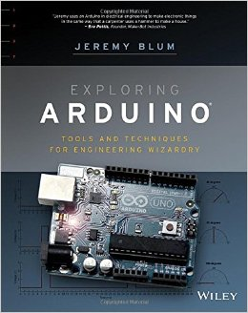
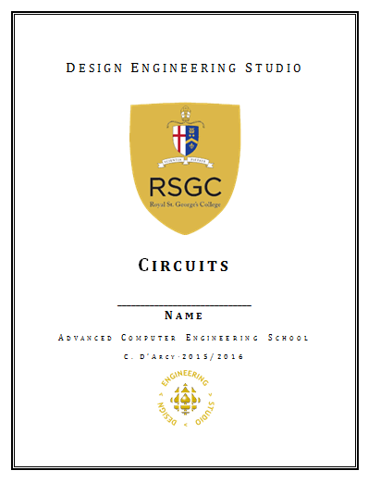

A Focus on Skills

RSGC’s three-year ACES program provides students with a unique set of practical skills that are developed in parallel with the acquisition of theory and knowledge of electrical, computer and software engineering concepts. It is only through the pursuit of working prototypes that assumptions can be fully challenged, oversights exposed and the unforeseen and unexpected behaviour of so-called ‘ideal’ components be tested. Furthermore, by the time students get to university, with their emphasis on theory-heavy curriculum, students (and their group partners!) will appreciate the advantage of a practical foundation in this domain.

Finally, potential employers are looking for candidates that go beyond a high GPA and can actually demonstrate their knowledge through the creation of physical prototypes.

Below is a partial list of skills introduced in each of our ACES’ courses.

Grade 10 (TEL3M)
1. Design Tools I (Fritzing)
2. Reading and Creating Schematic Diagrams
3. Breadboarding a Prototype
4. Troubleshooting (Debugging) Circuits
5. Design Tools II (EAGLE)
6. Using a Digital Multimeter
7. Through-Hole Soldering
8. Testing a Transistor
9. Technical Writing Skills
10. Advanced Word and Excel Techniques
11. Technical Presentations Skills
12. Time-Management Skills Involving Suppliers and Couriers

Grade 11 (TEI3M)
13. Computer-Assisted Drawing (ViaCAD)
14. Printed Circuit Board (PCB) Layout Design (EAGLE)
15. PCB Ordering and Fabrication
16. Arduino/C Programming
17. Online Database Search Techniques and Parts Ordering
18. Global Awareness and Outsourcing of PCB Manufacturing and Ordering

Grade 12 (TEI4M)
19. Surface Mount Soldering
20. ATMEL Assembly Language Programming
21. 3D Printing and Vacuum Forming
22. Building a Processor from TTL Chips
23. Teaching, Mentoring, and Technical Support for Younger ACES and DES Users

