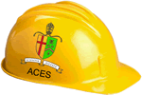
2015/2016 RSGC ACES Program

It is the belief of the RSGC ACES program that the majority of the leaders of tomorrow will emerge from the ranks of the makers and doers. To support our philosophy, we offer a sequence of three courses
designed to prepare engineering-minded Georgians for the future that we envision. Our curriculum can aptly be described as problem immersion with an emphasis on project-based solutions and skill development. Students engage continuously in problem-solving contexts with the primary aim of developing deeper thinkers. Design and communication technologies are fully integrated into the engineering technology process to produce remarkably comprehensive outcomes. Please tour our website to see the manifestation of our philosophy.
TEL3M ⎯ Circuits 10. This hands-on half-course builds on the Science 9 introduction to Electricity. Students work their way through concepts in and analog and digital circuitry employing curriculum designed specifically for our RSGC ACES program. Topics include power, prototyping, semiconductors, integrated circuits, communication as well as safety, environmental, and societal awareness. This course provides the foundation for our subsequent TEI3M Arduino 11 course.

TEI4M ⎯ C/Embedded Systems. Graduates of TEI3M deepen their interfacing experience in the context of client-based projects and solutions. The core curriculum is designed to prepare students for a smooth transition to university engineering programs that will require them to be comfortable with C programming and embedded systems using SMD components. The emphasis on project-based learning continues ranging from independent to team projects. The class project for this year is the design and implementation of a hand-held audio synthesizer.
University Placement in Computer, Electrical, Mechanical or Software Engineering Mathematics, or Science
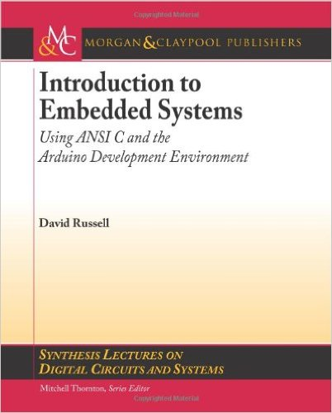
TEI3M ⎯ Arduino 11. Students are introduced to the architecture and implementation of microcontroller applications using the Arduino/AVR platform. Students explore analog and digital concepts including the binary number system, ADC and DAC, PWM and interrupts. Circuit board layout and production together with CAD/CAM exposure enables complete prototyping of projects based on light, sound, temperature, distance, pressure and power. This course provides the foundation for our subsequent TEI4M C/Embedded Systems course.

